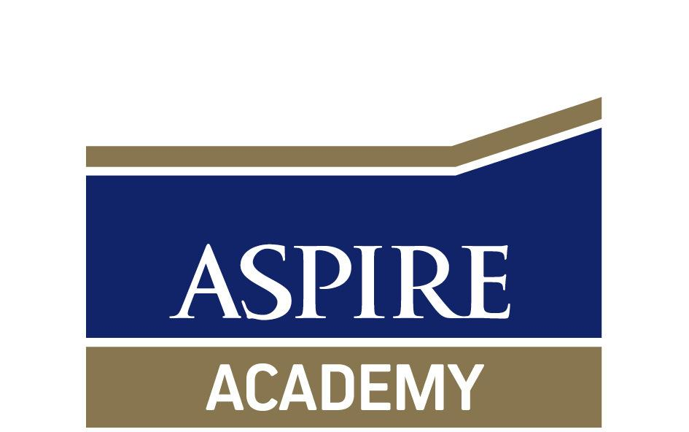
SEND Information

Aspire Academy
351 Annandale Road
Hull
HU9 5DE

(01482) 318789

lockyerh@aspirehull.com

SENCo - Holly Lockyer

Date of last review: September 2021
Date next review: September 2022

Definition of Special Educational Needs (SEN)
“A child or young person has SEN if they have a learning difficulty or disability which calls for
special educational provision to be made for them. A child of compulsory school age or a
young person has a learning difficulty or disability if they:

- have a significantly greater difficulty in learning than the majority of others of the same age; or
- have a disability which prevents, or hinders them from making use of educational facilities of a kind generally provided for others of the same age in mainstream schools or mainstream post-16 institutions.”
SEN Code of Practice 2014

Definition of Disability
‘A physical or mental impairment which has a substantial and long-term effect on the ability to carry out normal day-to-day activities’
Equality Act of 2010

The purpose of this document is to ensure that all stakeholders, including parents, teaching staff and governors understand and use a consistent approach in implementing support for young people with special educational needs.

Special Educational Provision
The Children and Families Act 2014 section 20 (C & F Act 2014 s.20) defines when a child or young person has special educational needs (SEN), this is when they have either a learning difficulty or a disability and they need special educational provision (SEP) to be made for them.
SEP is defined as any education or training provision which is additional to or different from that generally made for others of the same age in mainstream schools or post-16 institutions in England, as an Alternative Provision Academy, Aspire Academy are providing SEP for Alfie and the placement cost exceeds the notional delegated SEN funding.
Children and Families Act 2014

Special Educational Needs for Which Provision is Made
Aspire Academy currently supports children who have a range of special educational needs (SEN).
The Code of Practice 2014 describes four broad areas of SEN;
- Communication and Interaction, including speech, language and communication needs (SLCN) and Autism Spectrum Disorder (ASD).
- Cognition and Learning, including moderate learning difficulties (MLD), severe learning difficulties (SLD), profound and multiple learning difficulties (PMLD), Specific Learning difficulties (SpLD), including Dyslexia.
- Social, mental and emotional health, including attention deficit disorder (ADD), attention deficit hyperactivity disorder (ADHD), as well as other issues that are rooted in mental health.
- Sensory and/or physical needs, including a range of physical difficulties (PD) as well as hearing impairment (HI), visual impairment (VI) and multi-sensory impairment (MSI).

Policies for the identification and assessment of pupils with SEN.
- Any assessments made on entry to the school, or during the school year on a whole school basis. This may include reading tests, standardisation testing, CAT testing or well being tests.
- Details of any referral process whereby teachers are encouraged to raise concerns with the SENCo regarding the performance of pupils who they suspect of having special educational needs.
- Pupils who do not make adequate progress through the graduated approach may be further assessed by external agencies, such as the Educational Psychologist, IPaSS and Speech and Language Therapy Services.

Learning difficulties are also identified by using the following assessment systems:
- Teacher assessment
- Reading and numeracy assessment (BKSB/STAR Reading Test)
- Attendance, including lateness
- Use of internal professionals and outside agencies, where appropriate

Social, mental, emotional health difficulties are identified by using the following assessments:
- Monitoring of behaviour at Aspire Academy
- Attendance, including lateness
- Investigation of home issues
- Use of internal professionals and outside agencies, where appropriate

Once a need has been identified the Aspire Support Plan is written to address issues within the academy and to provide additional outside agency support where required.
Student progress is also monitored using the Aspire Support Plans.

Policies for making provision for pupils with SEN
The policies outlined in this section apply to all pupils with SEN, whether or not they have EHC Plans.
- The school closely monitors the progress of all pupils, including those with special educational needs. The effectiveness of the provision for these pupils is evaluated by ensuring that they make adequate progress. This will be reviewed termly as a minimum, by class teachers in collaboration with parents, the SENCo and the pupils themselves.
- Pupils who are receiving support that is additional to or different from their peers, due to special educational needs, will be assessed on a termly basis in all their subjects in line with the whole school policy of termly assessment of progress. In addition, these pupils may be assessed in more specific terms using more detailed testing, to evaluate their level of progress in their specific area(s) of difficulty.
- The approach to teaching pupils with special educational needs varies, depending upon the needs of the particular child. Some of the interventions that are used at Aspire are:
- In class support, where a teaching assistant (Tutor) may support one or more children to understand the content of the lesson.
- One to one withdrawal, where there may be targeted support in their area of need.
- English and Maths interventions to support pupils who show signs of difficulty with literacy and numeracy, both at KS3 and KS4.
- In-class support from a teaching assistant (TA/Tutor), where a higher level of support is required.
- All children are in groups for their lessons, where they work in a small class of between eight and ten pupils.
- Home tuition can, when appropriate, be provided.

- At KS4, a differentiated curriculum is provided offering a more practical range of subjects, designed to allow pupils with a variety of needs to be able to access learning and qualifications at a level appropriate to their abilities. Vocational qualifications form part of our curriculum offer at KS4.
Our approach to teaching and learning

Aspire Academy aims to be an inclusive school. This means that equality of opportunity must be a reality for all our pupils. We make this a reality through the attention we pay to the different groups in our academy, including pupils with special educational needs and/or disabilities and the variety of curriculum pathways we offer, to support individual student needs.

Teachers ensure that the work for these pupils:

a. takes account of their pace of learning and the equipment they use;
b. takes account of the effort and concentration needed in oral work, or when using, for example, visual aids;
c. is adapted or offers alternative activities in those subjects where pupils are unable to manipulate tools or equipment, or use certain types of materials;
d. allows opportunities for them to take part in educational visits and other activities linked to their studies and enrichment opportunities whenever possible;
e. uses assessment techniques that reflect their individual needs and abilities to ensure all students make both social and academic progress.

At Aspire Academy we are committed to giving all our pupils every opportunity to achieve the highest standards and to do this, our starting point is planning a curriculum that meets the specific needs of individuals and groups of pupil(s).

We do this through overcoming potential barriers to learning and focusing on the additional needs of the individual student that will help them succeed. We provide additional curriculum opportunities to meet the needs of individuals or groups of pupils and provide access to the life of the Academy for all pupils. (This includes speech and language therapy, physical management programmes, student counselling or listening services, anger management, and behaviour modification programmes.)

Contact details of the SEN Coordinator

SENCo name: Miss Holly Lockyer
Contact Telephone number: (01482) 318789
Email: lockyerh@aspirehull.com

Expertise and training of staff in relation to children and young people with special educational needs
- Existing training already undertaken, including Safeguarding Level 1 for all teaching and support staff.
- Ongoing policy of CPD for all staff including teachers, teaching assistants and ancillary staff on special educational needs and specific Level 2 qualifications in Mental Health, Adverse Childhood Experiences, Trauma and Attachment.
- Staff will seek training from outside support agencies when necessary including outreach and transitional support (see local offer for list of external agencies)
- Specialist staff will also attend training courses provided by the local authority.

Equipment and facilities to support children and young people with special educational needs

All needs for equipment and facilities will be assessed for each pupil individually. Depending upon the nature of the need, funding may be provided by the school or requested from other appropriate agencies.
These may include IPASS, who can provide specialist equipment for physical, visual, and
hearing needs.

Arrangements for consulting parents of children with special educational needs about the education of their child
Parents/carers are involved at each stage of the ‘assess, plan, do and review’ process. Parents/carers are invited to discuss with the SENCo (and/or class or link teacher/tutor) the needs of their child in the first instance.
This allows for parents to share knowledge about their child and engage in a positive discussion from which there will be agreed actions relating to how the child’s needs can be met. Therefore parents/carers have an active role in the planning and decision making regarding their child’s provision.
Subsequent to this, parents/carers will be kept informed of progress and outcomes as a result of the aforementioned actions in a number of ways:-
- Liaison with the class/link teacher and tutor informally.
- Regular meetings/communication when advice and support in helping their child at home can also be given.
- Formal review of their child’s progress with the SENCo (and/or class teacher/form tutor).

During these meetings/discussions, a ‘person centred approach’ allows for professionals and parents/carers to contribute towards reviewing the effectiveness of provision in place for the child. Following this, decisions can be made regarding next steps.

Arrangements for consulting young people with special educational needs about their education

- The child/young person is involved (as is appropriate) at every stage of the assess, plan, do, review process:-
- At the initial assessing and planning stage, in order to support a ‘person-centred approach’, the child/young person’s wishes and aspirations are taken into consideration, along with the outcomes they seek and the support they need to achieve them. These discussions enable individuals to feel that they have more control over decisions about their support.
- Where the child/young person may be unable to verbally communicate or provide a written input, observations of the child/young person may be made in order to gather information regarding their likes, interests, dislikes and difficulties.
- The thoughts and opinions of parents/carers, and those who know them best, may also be sought.
- Any documentation used as a part of the agreed provision (for example, Support Plan or similar) will have a ‘child friendly’ section which is shared with the child/young person so that they are able to understand all aspects of their support.
- The child/young person is able to discuss any aspect of their provision in a number of ways:-
- Informally with their class/form teacher on a regular basis.
- Where appropriate, the child/young person will attend a more formal meeting to review their progress and provision.
- A child/young person may contribute to this meeting either by attending in person or by providing written input.

Any arrangements made by the governing body or the proprietor relating to the treatment of complaints from parents of pupils with special educational needs concerning provision made at the school

Complaints about SEN provision within the school are first dealt with by the SENCo, Mrs Read, during arranged meetings.
Where a satisfactory conclusion cannot be reached, the parent can then make an appointment to see the Principal, Mr Mulqueen, during which further information can be exchanged and procedures altered as appropriate. If a satisfactory conclusion still cannot be reached then the Governing body must become involved.
Aspire Academy participates fully if receiving requests for information for tribunals or assisting parents in formulating appeals etc.

How the governing body involves other bodies in meeting the needs of pupils with special educational needs

Where a school has concerns that a child may require additional or external support to meet their special educational needs, then a request can be made to the local authority service provider and / or other professional support service, or voluntary organisation. These may include:
- Educational Psychologists
- Speech and Language Support Agency
- ASD Team
- National Autism Society
- IPaSS – Integrated Physical and Sensory Service(Visual/Hearing/Physical)
- Social Care Team
- Children’s Centres
- CAMHS for Mental Health Needs
- Kids – Parent Partnership
- School Nursing Team
- Cruze / Dove House Bereavement Support Team
- Sibling Support Services – Barnardo’s
- Northcott Outreach Service
- Police

Links to all of these can be found in the Hull Authority Local offer, available at: Hull’s Local Offer
Advice may be sought from one or several service providers, when considering the initiation of a statutory assessment. Details of this may be found in the DFE SEN Code of Practice.
A Statutory Assessment is only usually required or conducted for children with complex or severe learning needs. This may include needs in;
- Cognition and Learning
- Communication and Interaction
- Social, mental and emotional health
- Sensory and/or Physical
Throughout this process the local authority has a duty to request the opinions of parents, the school and other involved professionals.
Following a Statutory Assessment, the local authority will make a decision whether an Education Health and Care Plan is considered appropriate for the child.

The contact details of support services for the parents of pupils with special educational needs, including those for arrangements made in accordance with clause 32.

All contact details are detailed in the links provided in the Hull Authority Local Offer

Arrangements for supporting pupils with special educational needs in transferring between phases of education or in preparing for adulthood and independent living.
All children with special educational needs will require support and planning when they transfer between key stages from 0-25.
For example:
Preschool -> Nursery -> Foundation -> KS1 -> KS2 -> KS3 -> KS4 -> KS5 -> Higher Education/College -> Independent Living.
Where a child has an Education Health Care Plan, a preference for educational setting should be made during the Annual Review process the year prior to the transition. This enables the local authority to consult and request placements at the preferred school.
Students with an Education Health Care Plan, will, in year nine be seen by a careers advisor to discuss appropriate Further Education/Apprenticeships or training post 16.
Depending upon the school’s setting, they may wish to elaborate on the specific arrangements that they have in place to support pupils with SEN through the transitions they are involved with.

Information on where the local authority’s offer is published
What is Hull's Local Offer?
In Hull there's lots of support available to children with disabilities and special educational needs, and their families. You'll find information about that Local Offer of support here (see link below). Whether it relates to education, health, social care or parental support, and regardless of who's providing it, we'll aim to point you in the right direction.
http://hull.mylocaloffer.org/s4s/WhereILive/Council?pageId=3018&lockLA=True

Access to the Curriculum
Students with SEN have access to a broad and balanced curriculum alongside their peers. A number of strategies are employed to ensure this takes place. These include the provision of additional adult support, small group placements and settled provision. Resources matched to students' needs are produced and developed. Accredited courses are made available to Key Stage 4 students for whom a full range of GCSE subjects is not appropriate.
The academy monitors and sustains its SEN strategies through regular consultation with staff during the regular cycle of meetings.

EAL Provision
Particular care will be needed for students whose first language is not English. Teachers will closely follow their progress across the curriculum to ascertain whether any problems arise from uncertain command of English. It will be necessary to assess their proficiency in English before planning any additional support that might be required.
Please refer to the EAL Policy for further information regarding EAL Provision at Aspire Academy.

‘Work alone spaces’
As part of Aspire's commitment to each and every one of our students, we aim to support all students both academically and socially. As such, "work alone spaces' ' are available within classrooms with the aim to provide a space away from others, within the classroom, to reduce overstimulation and will be used positively, not punitively, to allow students to focus on their work within their tutor/classroom.
Students simply need to inform their tutor or classroom teacher that they wish to work at the 'staff desk', as part of one of their identified strategies, for a break away from their normal work space, to allow them time to refocus their mind on the task at hand. This information can also be found within each classroom to ensure students are aware of this opportunity.

Evaluating the effectiveness of SEN provision
We evaluate the effectiveness of provision for students with SEN by:
● Reviewing students’ individual progress towards their goals each term
● Reviewing the impact of interventions
● Using pupil questionnaires
● Monitoring by the SENCo, Mrs Read
● Using provision maps
● Holding annual reviews for students with EHC plans

Pupil Information
Aspire is an Alternative Provision academy for students aged 10-16. At the end of the Summer Term 2021 there were 143 students on roll. The peak roll number was 245 within the year.
The vast majority of students enter well below their KS2-4 pathway expectations (Average 2.5 grades from expected performance). A significant number have a reading age well below their chronological age (61%). FSM, PP and SEN EHCP are high and are significantly above the national average. (59%, 69% and 31%.)
High proportions of those who do not have an identified need and a number are in the process of assessment. Baseline assessment on entry demonstrates students have significant social, emotional and mental health needs.

Progress
Aspire’s GCSE and equivalent results are consistently good, historically 99% of students achieving a minimum of 5 GCSEs including English and Maths. This figure was 100% for 20/21. Almost 37% achieved a minimum of 5 GCSEs including E&M at grade 4 or above in 20-21. A slight increase from 33% the year before. 90% of students registered for vocations achieved their pathway.
The students not achieving their pathway did achieve more highly in their academic studies than their original target. ABALS assessments demonstrate an average of 15% in year improvement, per student, from baselines in 2020/2021 demonstrating a successful approach to building personal resilience and personal management skills.
Students leave with a range of qualifications and qualification types enabling them to progress to a wide range of post-16 provisions and employment. The average number of GCSE (or equivalent) in 20-21 was 7.3 and 7.4 in 19-20 demonstrating the curriculum was not narrowed in response to Covid-19.

Destination Data
The DfE study 'Characteristics of young people who are long term NEET (published February 2018) suggests up to 41% of NEETs nationally were excluded students/students in AP. NEETS were 3.6% in 19/20, which is significantly lower than the national average for AP. Figures for 2020/21 is 5.20%.

